**Installation Guide**

What you need?

* Internet Access
* Python
* PyCharm
* 01 – Dylan Liew Hock Cong.zip

Configure Interpreter

1. Run PyCharm
2. In the Welcome to PyCharm dialog box, click Create New Project

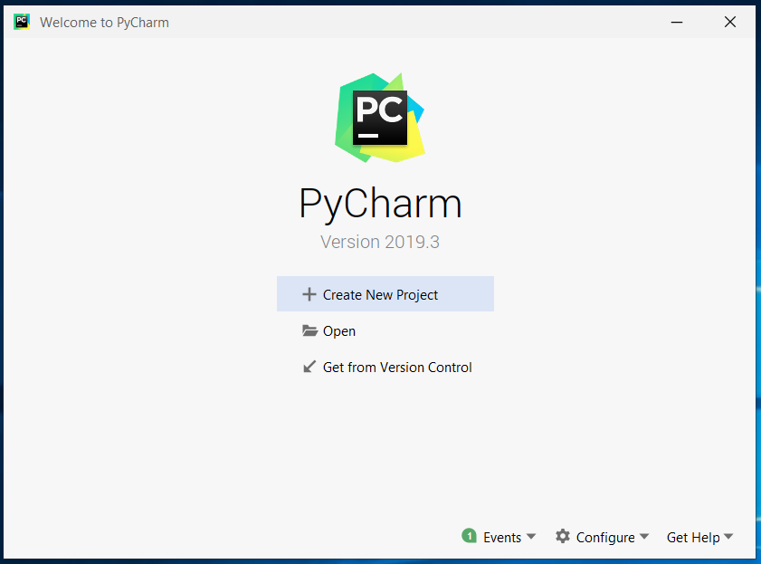

1. In the New Project dialog box, enter DylanProject and click Create.

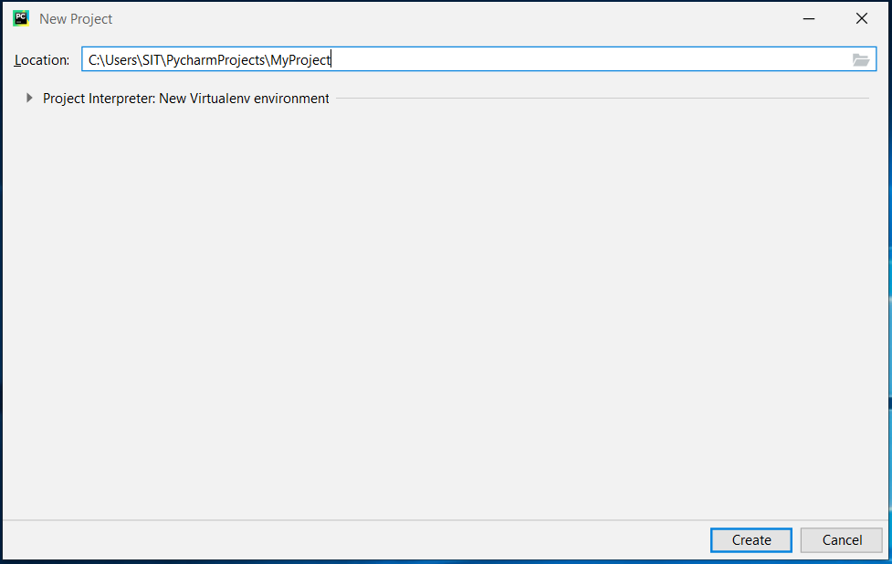

1. In the DylanProject Window, File -> Settings -> Project: Dylan Project -> Project Interpreter -> Click on the + icon, then search for Flask (1.1.2), PyCryptodome then install it.
2. Next, go to 1 – Dylan Liew Hock Cong and open the folder, CryptoApp and copy all the content and paste it in DylanProject.
3. Installation Done !